Installation Instructions
Thank you for purchasing your E30 bearing conversion kit. Let’s get these bad boys installed!
Wheel studs: Please follow the attached Bimmerworld instructions for installation. I find that an old rotor clamped in a vice allows you to torque the studs easily. You could also install the hubs and have a friend hold the brakes for you. Two lug nuts stacked up work well for torqueing. If you reuse these studs use blue Loctite to keep them from loosening over time.
Spindle sleeve: The sleeve slides over your spindle with tapered end towards the spindle. These are a precision fit so if the sleeve doesn’t slide on please clean up your spindle with a scotch bright pad or emery cloth. A light coat of grease or anti-seize on the sleeve will help prevent corrosion.
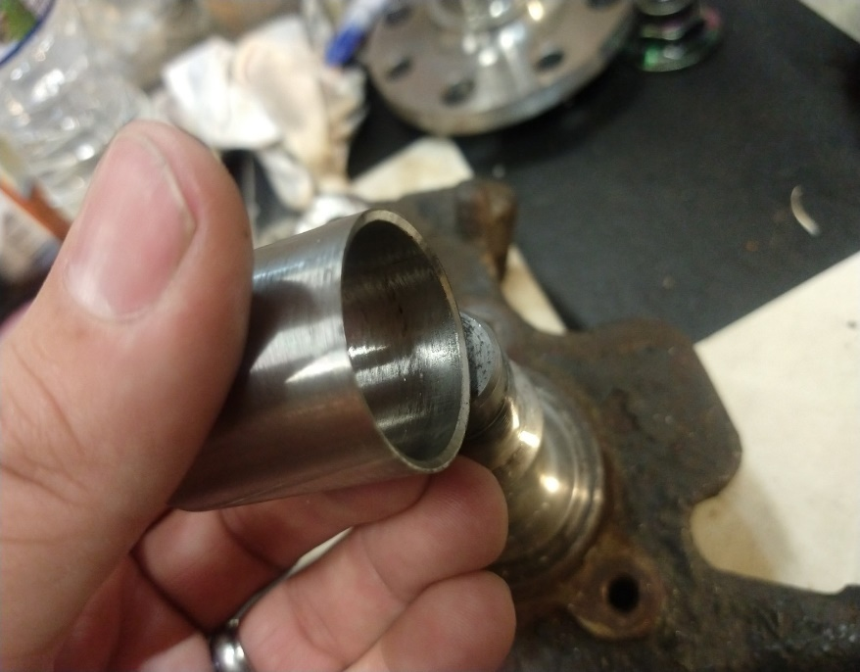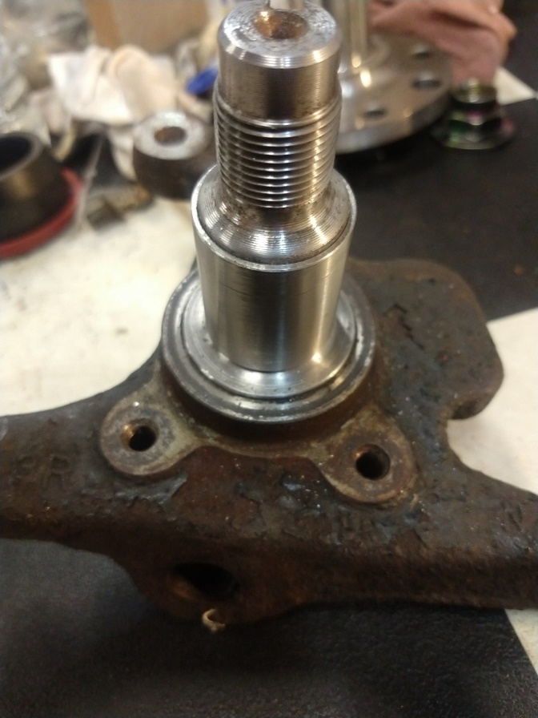

Heavy Duty Washer: This slides on with the machined surface towards the bearing. The axle nut installs on top of this and is torqued to the Miata specific 123-159 ft/lb. O-ring sits on bearing as shown to prevent grease from escaping at high temps.
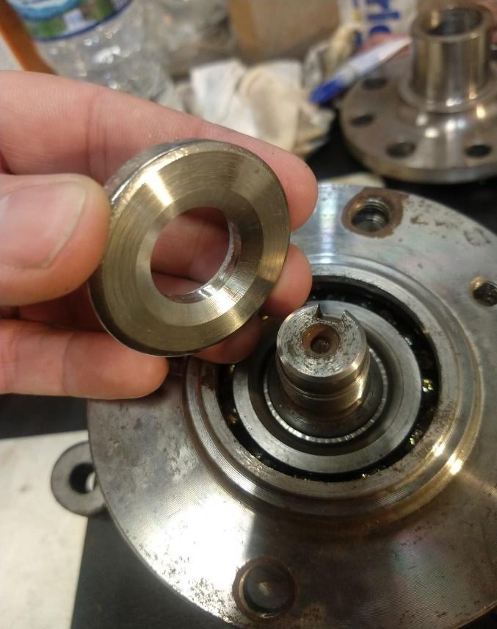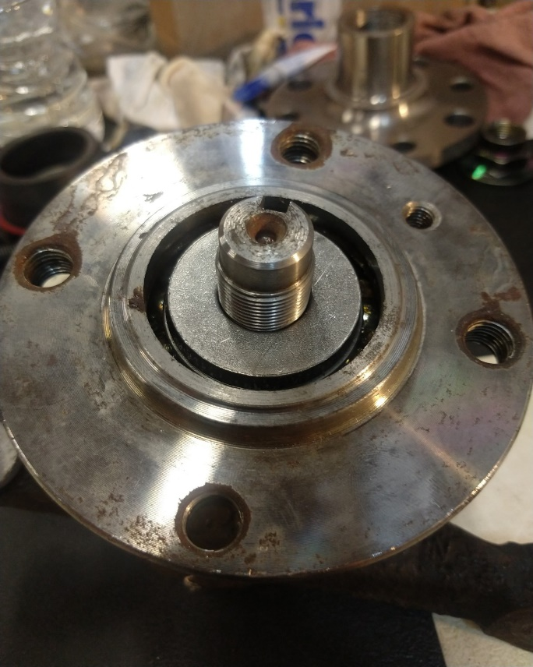
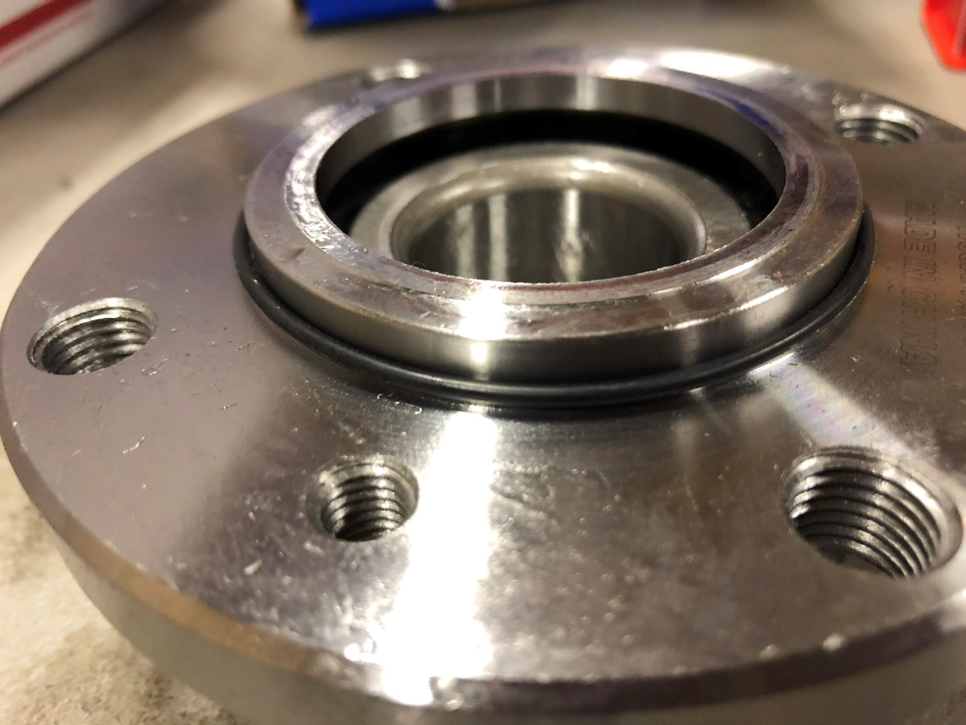
Wheel spacer: Just slides
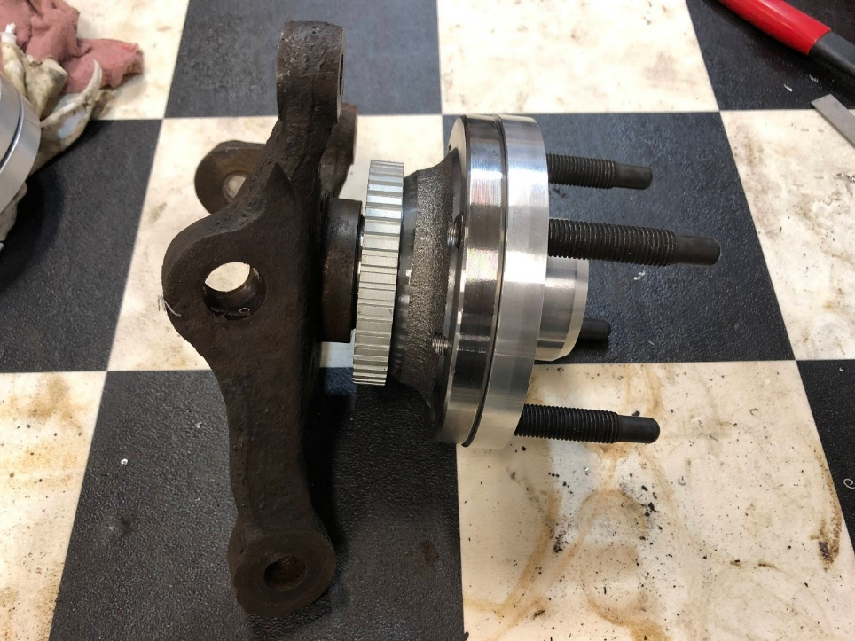
Your brake hardware will now install on top of the spacer just as it would with the Miata bearing.

Modifying your own bearings:
The original intent of this project was to be able to run to the parts store and grab a bearing off the shelf if you ever found yourself in a bind. Unfortunately, to maintain Miata brake hardware and wheels there is a machining process that needs performed on the bearings before they can be used. The pictures below show the protrusion that needs to be removed from the bearing for the spacer to seat correctly. This can be removed with just about anything, band saw, angle grinder, angry beaver you name it. Of course, a lathe makes for a clean final product. The protrusion needs removed down to just above the brake rotor register, a quick test fit of the spacer will tell you if you have machined far enough. Make sure you stuff the bearing cavity full of paper towels or a shop rag to keep the metal shavings out of the bearings. I turned a Delrin plug for production purposes.
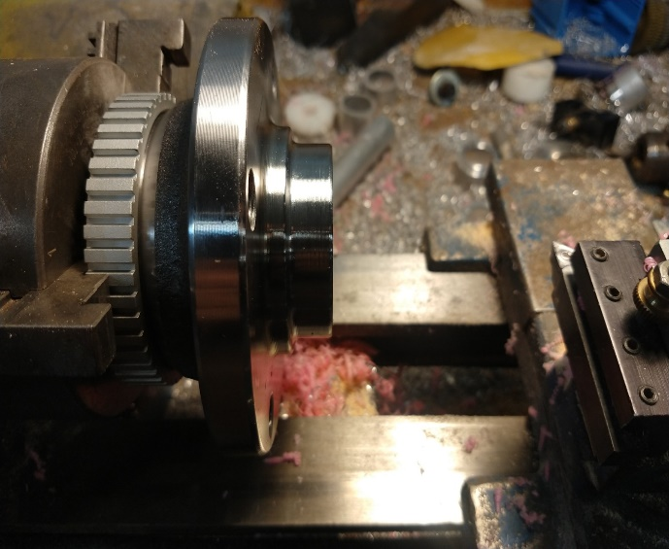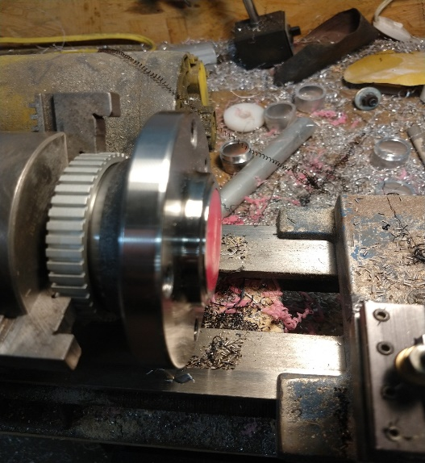
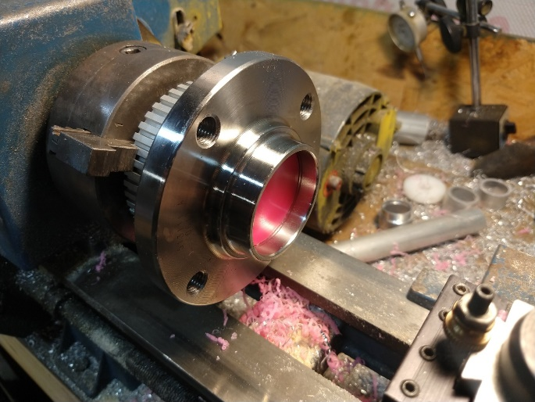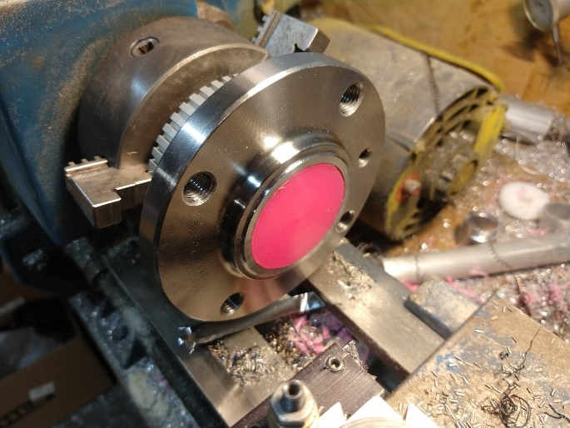

For technical support please don’t hesitate to reach out to me.
Bronson McNemar
Call or text: 304-439-1149
BronsonWM@gmail.com

